Written questions

1.Signal Pre-processing

a)

32 bits = 4 bytes

44100\*4\*20 = 3528 Kbytes

b)

Frame size N: 44100\*60 ${10}^{-3}$\* = 2646 samples

Non-Overlapped m : 2646 \* 50% = 1323 samples

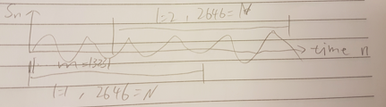

c)

Should be 44100/2 = 22050 Hz

Because sampling frequency is 44.1 Khz, so the range of frequency should be 0 - 22050 Hz.

2.

There is always a trade-off between picking larger window size and smaller window size. Larger window size gives you better frequency resolution because that you have more samples in one window for the fft, there will be more bins (Xm as described in slides) for the frequency, thus larger window size result in higher frequency resolution. On the contrary, smaller window size result in higher time resolution. Means increase frequency resolution will decrease time resolution, same in the opposite way.

2 Linear Predictive Coding

1.

Base on 

We can calculate

2. =

matrix for solving LPC.

3.Matcing technique

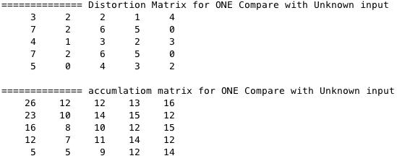

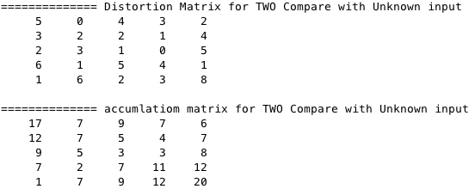

As we can see the accumulate matrix of ONE compare with Unknown, the total accumulated value is 12 found on center position of first row.

And total accumulated value for TWO compare with unknown input is 6 found on top right corner of the matrix.

Thus, The unknown input is “Two”